Backend note
Array List is a resizable array that can grow as needed. It allows you to store elements and access them by index.
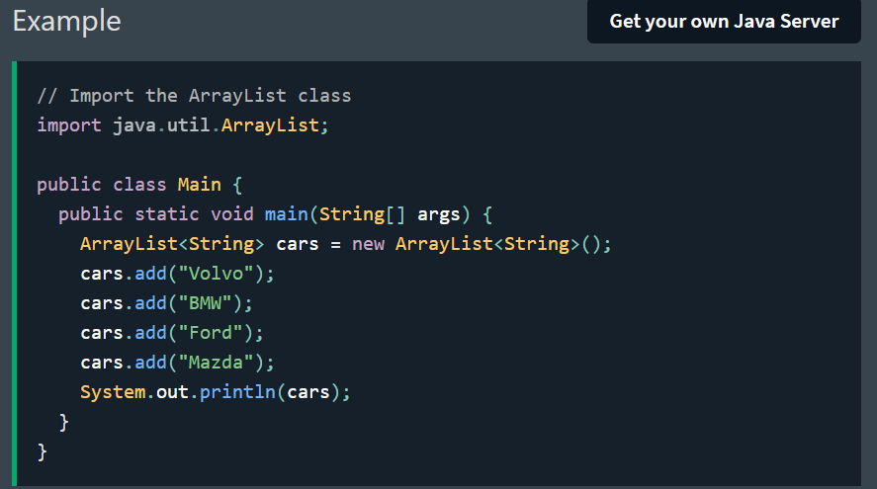

HashSet is a collection where every element is unique. No duplicates are allowed.
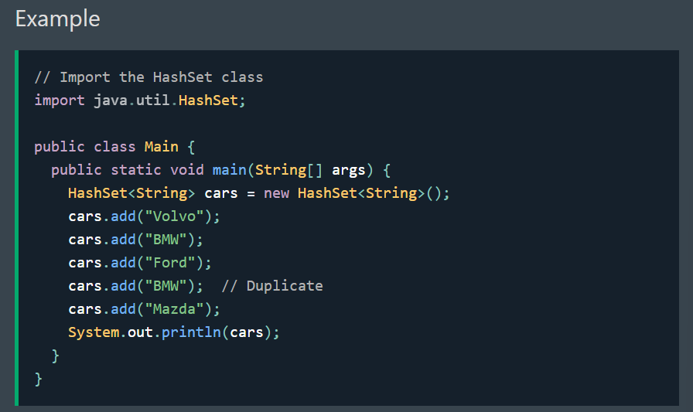
HashMap stores key-value pairs, which are great when you want to store values and find them by a key like a name and ID.
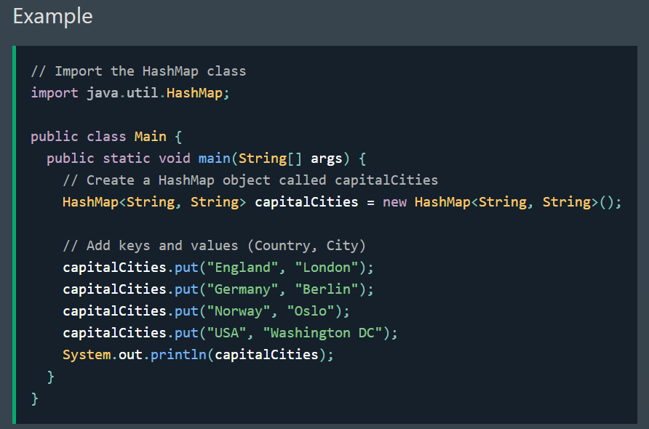

Iterators
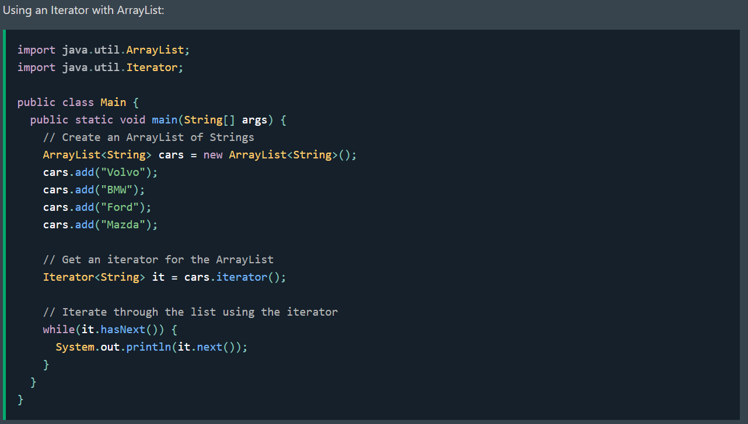
The collection of frameworks
The Java Collections Framework provides a set of interfaces (like List, Set, Map) and a set of classes (ArrayList, HashSet, HashMap) that implement those interfaces.
They are used to store, search, sort and organize data more easily – all using standardized methods and patterns.
Interface | Common classes | Description
List | ArrayList, LinkedList | Ordered collection that allows duplicates
Set | HashSet, TreeSet, LinkedHashSet | Collection of unique elements
Map | HashMap, TreeMap, LinkedHashMap | Store key-value pairs with unique keys

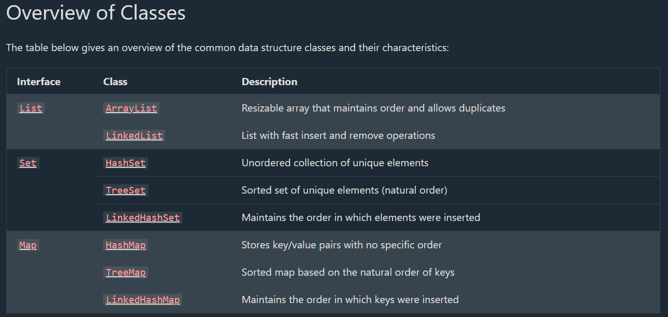

Use List classes when you care about order, you may have duplicates, and want to access elements by index.
Use Set classes when you need to store unique values only.
Use Map classes when you need to store pairs of keys and values, like a name and its phone number.

Java List Interface
The List interface is part of the Java Collections Framework and represents an ordered collection of elements.
You can access elements by their index, add duplicates, and maintain the insertion order.
Since List is an interface, you cannot create a List object directly.
Instead, you use a class that implements the List interface, such as:
- ArrayList - like a resizable array with fast random access
- LinkedList - like a train of cars you can easily attach or remove
Tip: Use List when you care about order, you may have duplicates, and want to access elements by index.

